The exploration and research of obesity

Background:
Nowdays, obesity is rapidly becoming a universal worldwide health problem that troubles people. It is a chronic health condition associated with having excess body fat and is a leading cause of serious conditions such as diabetes, high blood pressure, heart disease, stroke, arthritis and cancer. Obesity is associated with a list of complex factors including eating habits, life style, and physical conditions. According to the 2014 Canadian Community Health Survey, over 5 million adults have obesity and according to the 2015 Canadian Health Measures Survey, 30% or more than one in three adults in Canada has obesity and may require medical support to manage their disease. Obviously, the research of obesity is demands and challaging.
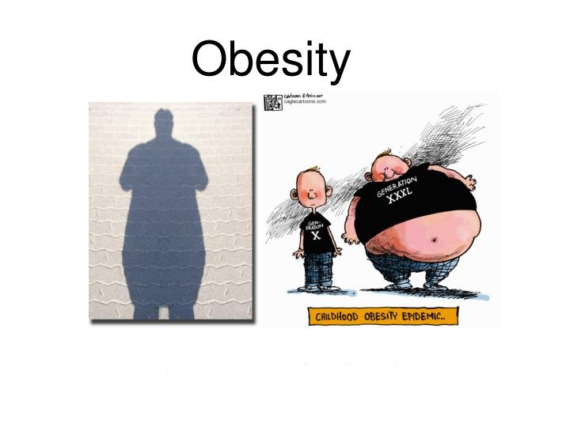
Organization Information:
We are Obesity Canada, which is Canada’s leading obesity charity, made up of healthcare professionals, researchers, policy makers and people with an interest in obesity. As A growing number of people are suffering from obesity. Our organization decide to find the major causes of obesity through data research and provide some health advice for individuals and help them manage and overcome obesity.
Project Object:
Identify the main causes of obesity and provide health advice for individuals development.
Approch:
The project will analyze the dataset through the data visualization tool named Tableau. Finally present the overwight and obesity status and major causes, produce health advises for individuals.
Data Set Information:
Dataset: ObesityDataSet_raw_and_data_sinthetic.csv
This dataset include data for the estimation of obesity levels in individuals from the countries of Mexico, Peru and Colombia, based on their eating habits and physical condition. The data contains 17 attributes and 2111 records, the records are labeled with the class variable NObesity (Obesity Level), include Insufficient Weight, Normal Weight, Overweight Level I, Overweight Level II, Obesity Type I, Obesity Type II and Obesity Type III. 77% of the data was generated synthetically using the Weka tool and the SMOTE filter, 23% of the data was collected directly from users through a web platform.

